Events and Delegates

The project currently has 3 main components (relevant to this topic). There is an EncounterGenerator, GridManager, and the Tiles the grid manager creates. The project is an isometric tile-based game in its very very early development.

The EncounterGenerator (using the Encounter.cs script) is currently responsible for telling the GridManager (using the IsoGridgen.cs script) to spawn a grid. The EncounterGenerator is also responsible for moving the player around, however, the method to move the player comes from the individual tiles when clicked.

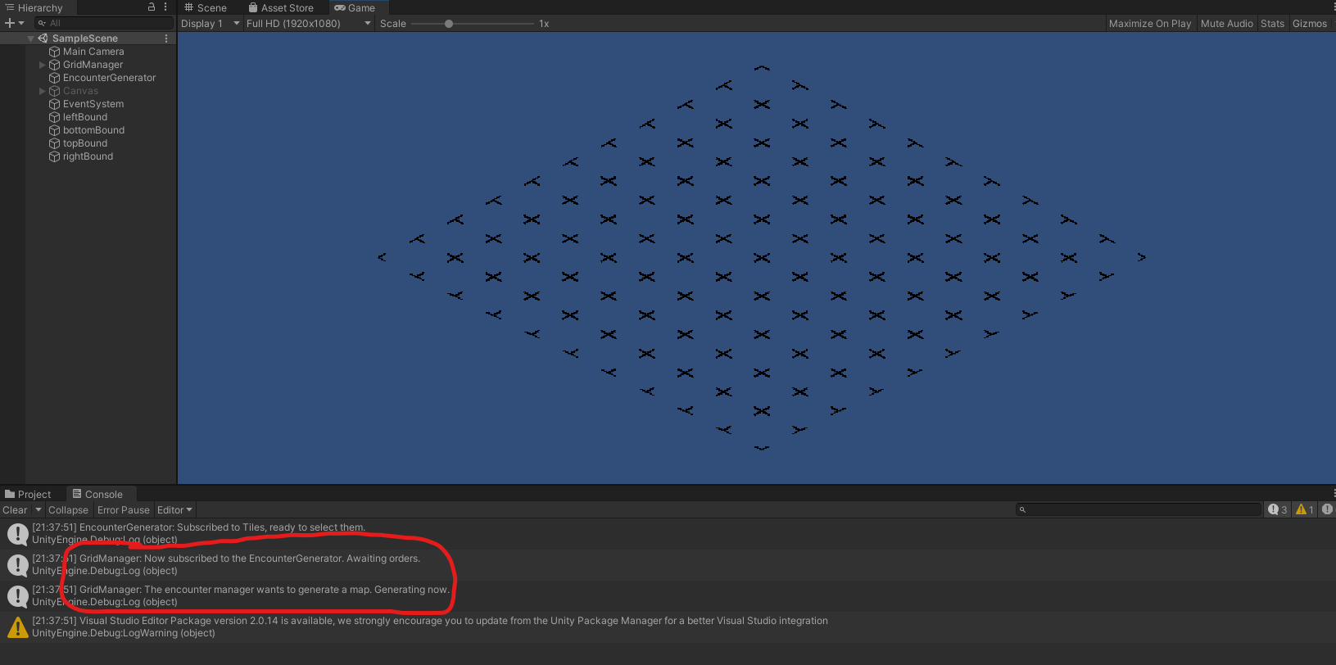Example one: creating the map

Currently, when the game starts, the GridManager immediately subscribes to the EncounterGenerator and awaits the order to generate the map using the GenerateGrid() method. Right away, the EncounterGenerator sends the ‘genTiles’ event to get it going.

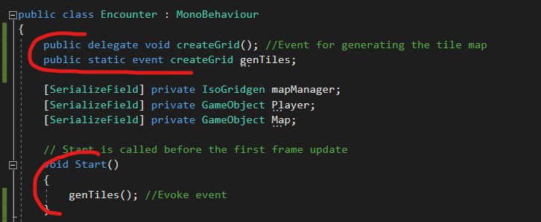 EncounterGenerator’s script:

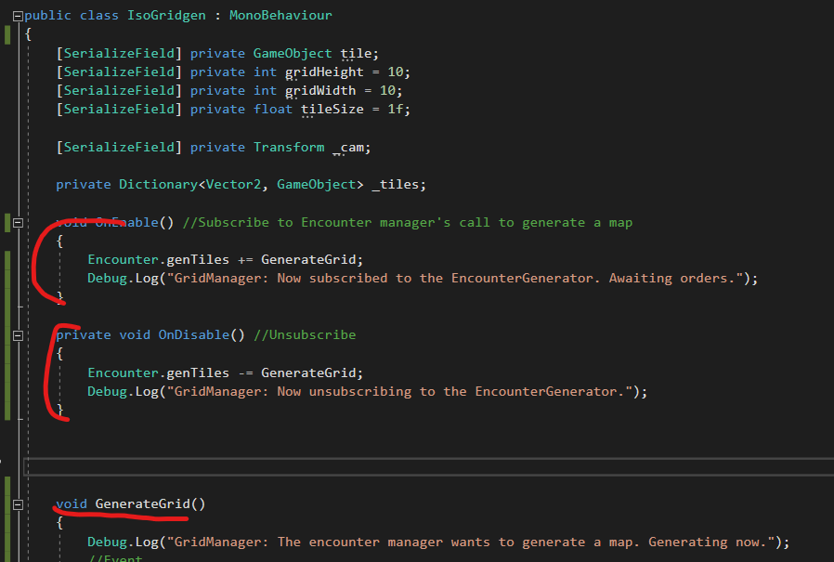GridManager’s script:

Example two: moving the player

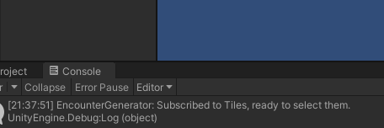

At the beginning, the EncounterGenerator listens to the tiles as they are spawned.

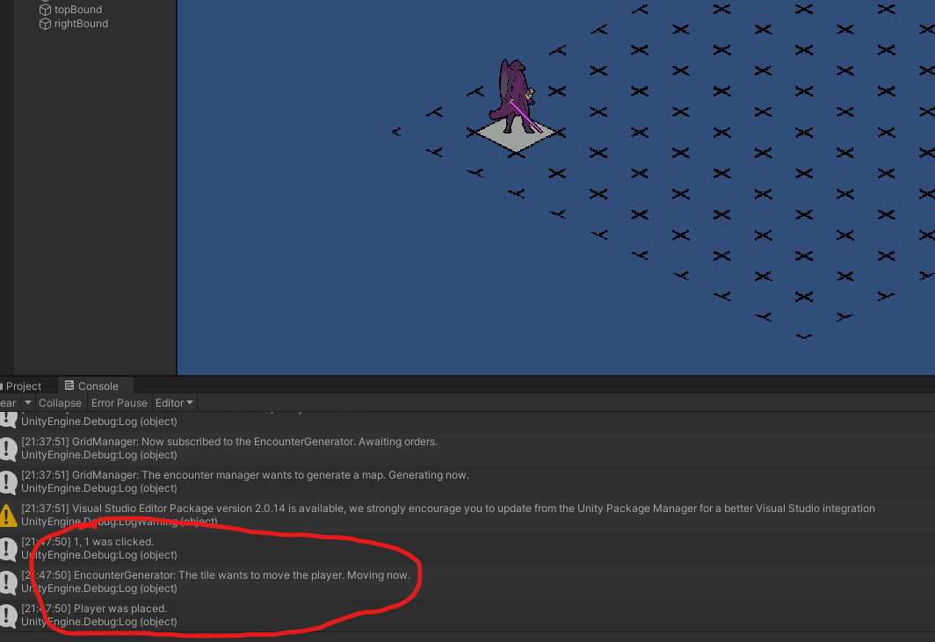

When a tile is clicked, the tiles call back to the encounter to move them using the overloaded ‘placePlayer’ script. This also passes an argument, that being the gameObject clicked, so the script knows where to place the player character.

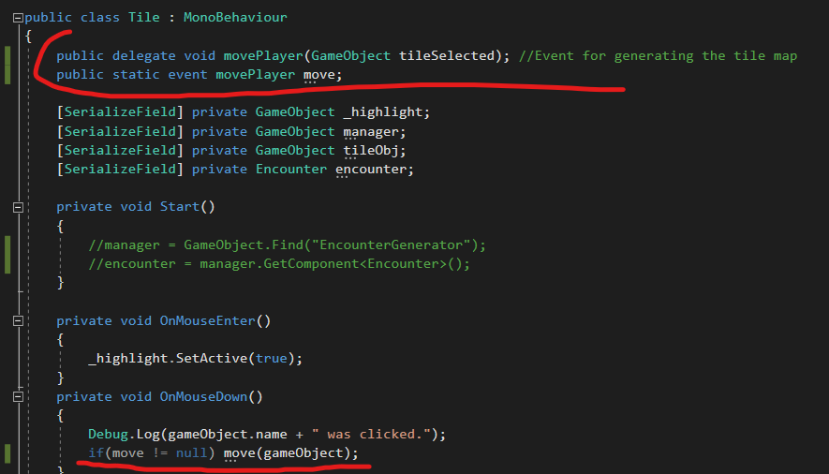The tile script (Tile.cs):

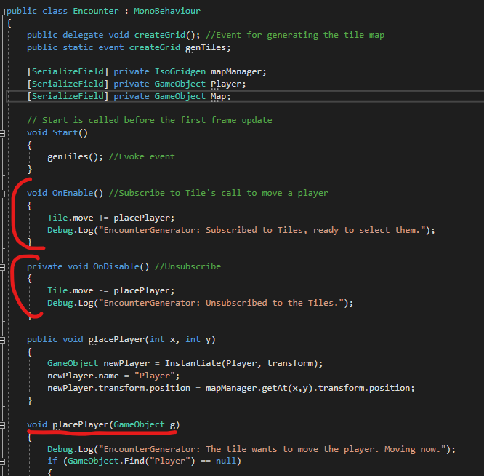Encounter’s script: